TODO:
לכתוב מתחת לכל דיאגרמה/איור מספר + הסבר + מקור אם יש - נוי
להוסיף את התיעוד בגיט - טל
לעשות רשימת מקורות וביבליוגרפיה – נוי + טל
לסדר את התוכן עניינים - נוי
להוסיף תמונות בנספחים!! ולכתוב בתוך הניסוי הפנייה לתמונות בנספחים! - טל



Insert the Project Title here

Project Number:

Project Report

Student: |  | ID:
Student: |  | ID:

Supervisor:

Project Carried Out at:

Contents
Abstract 3
1 Introduction 5
2 Theoretical background 9
3 Planning 14
4 Implementation 18
Hardware Description 26
4.3 Software Description 27
5 Analysis of results 31
5.1 Machine Learning 31
5.2.2 Cole-Cole Model Fitting – Potato Phantom 34
6 Conclusions and further work 40
7 Project Documentation 45
8 References 46
Appendix A. Subject 1 48
Appendix B. Subject 2 49

List of figures
Figure 1: Block diagram 2
Figure 2: The System 6
Figure 3: Amplifier Input Circuit 6

List of tables
Table 1: Results 8

List of equations

Abstract
Measuring how much milk an infant consumes during breastfeeding is an important clinical challenge. Current methods, such as weighing the infant before and after feeding, are cumbersome, indirect, and unsuitable for continuous real-time monitoring. This project proposes a non-invasive wearable sensing approach for estimating breast milk volume changes using bioimpedance measurements.
Our project is based on the physical principle that breast milk, as an extracellular fluid with higher conductivity than surrounding tissues such as fat and skin, affects the electrical impedance of breast tissue. As milk is released during breastfeeding, tissue conductivity decreases and the measured impedance increases, especially in low-frequency regimes.
The hardware system in the project is built around the MAX30009 Analog Front-End (AFE) connected to an Arduino Nano 33 BLE. The system is designed to acquire multi-frequency impedance data from four electrode pairs and transmit the measurements wirelessly to a PC for processing.
On the software side, raw impedance spectra are transformed into physically meaningful parameters using the Cole-Cole bioimpedance model, which represents the frequency-dependent electrical behavior of biological tissue. These features are then used to train a LightGBM gradient-boosted tree regression model to estimate the volume of milk consumed between two time points within a feeding session.
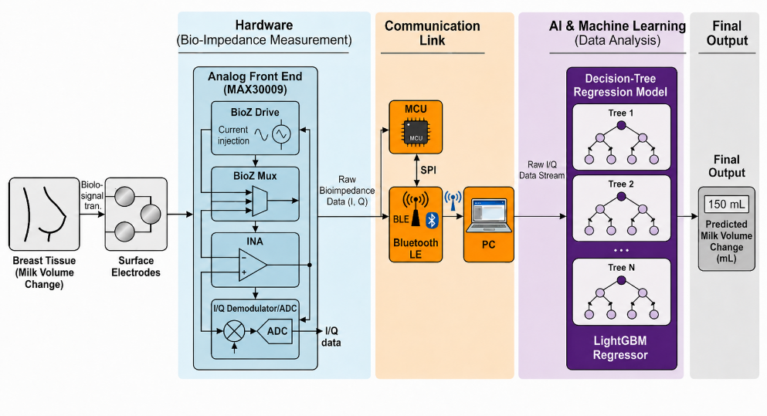

Figure 1: Block diagram

Introduction
Breastfeeding has a central role in infant nutrition, immune protection, and healthy physiological development. Human milk provides essential nutrients and biological components required for neonatal growth, and successful breastfeeding is therefore an important goal in both clinical and home-care settings. However, one of the main challenges during breastfeeding is the inability to accurately determine how much milk an infant consumes during a feeding session.

Today, milk intake is commonly estimated by weighing the infant before and after breastfeeding. Although this method can provide an approximate indication of consumed milk volume, it is indirect, inconvenient, and unsuitable for continuous real-time monitoring.

The motivation for this project comes from the need for a simple, non-invasive, and continuous method for estimating breast milk consumption. Such a system could help reduce uncertainty for parents and clinicians, support infant nutrition tracking, and provide a more objective indication of whether the infant receives a sufficient amount of milk. This need is especially important in cases involving premature infants, low milk production, feeding difficulties, or clinical follow-up of infant growth.

The goal of this project is to develop a proof-of-concept system for estimating changes in breast milk volume using bioimpedance measurements. The project combines hardware development, physiological modeling, and machine learning.
The engineering Objective is to develop a wearable system for real-time estimation of milk volume changes using bioimpedance measurements and a regression based learning model.

To solve the problem, the project uses Bioimpedance Spectroscopy (BIS), in which impedance is measured at multiple frequencies rather than at a single frequency. Multi-frequency measurements provide richer information about the electrical behavior of biological tissue and allow the system to capture frequency-dependent changes related to fluid composition.
Our system operates by placing skin electrodes on the breast and applying a small, safe alternating current at several frequencies. The measured impedance spectrum is acquired at multiple time points throughout a feeding session.

The physical principle behind the project is that breast milk behaves as an extracellular conductive fluid. Since milk has higher electrical conductivity than surrounding tissues such as fat and skin, changes in milk volume affect the measured electrical impedance of the breast.

On the hardware side, the system based on the MAX30009 Analog Front-End (AFE) connected to an Arduino Nano 33 BLE microcontroller. The hardware is designed to acquire multi-frequency impedance data from two electrode pairs and transmit the measurements wirelessly to a PC for further processing. On the software side, the raw impedance spectra are transformed into physically meaningful features using the Cole-Cole bioimpedance model. These features include low-frequency resistance, high-frequency resistance, characteristic frequency, and dispersion exponent, which compactly describe the electrical response of biological tissue.

After feature extraction, a machine-learning regression model is used to estimate the change in milk volume between two time points within a feeding session. Several learning models were evaluated, including LightGBM, Multi-Layer Perceptron (MLP), and 1D Convolutional Neural Network (1D CNN).

Compared with existing methods, the proposed system aims to provide a continuous, non-invasive, and wearable alternative to infant weighing. Instead of relying on external scales or post-feeding measurements, the system estimates milk volume changes directly from physiological impedance signals.

A recent study published in Nature Biomedical Engineering demonstrated the feasibility of monitoring breast milk volume using a compact wireless bioimpedance system. The researchers showed that changes in breast milk volume during feeding lead to a measurable increase in breast impedance and established an approximately linear relationship between impedance variation and milk volume. Their sensing approach relied on a selected operating frequency, 16 kHz.

Our project is based on the same physical principle but extends it in both the measurement method and the estimation approach. Instead of relying on a single-frequency impedance measurement and a predefined subject-specific linear calibration between resistance and volume, our system performs BIS over a range of frequencies and learns the nonlinear relationship between the impedance spectrum, tissue conductivity, and fluid-volume changes. This allows the system to capture a richer frequency dependent representation of the breast tissue response during milk removal.

In addition, our project transforms the multi frequency impedance spectra into physically meaningful features using the Cole-Cole bioimpedance model and trains a regression model to estimate the amount of milk consumed during a feeding session. Therefore, while the Nature study provides the scientific foundation by proving that milk removal produces measurable impedance changes, our project introduces an engineering extension: a multi-frequency, physics-informed, machine-learning-based framework for real-time milk volume estimation.

Theoretical background

2.1 Bioimpedance
Bioimpedance is the opposition of biological tissue to an applied alternating electrical current. Unlike simple resistance, impedance is frequency-dependent and generally has both a real and an imaginary component. The real component represents resistive behavior, mainly related to conductive fluids, while the imaginary component represents reactive or capacitive behavior, mainly related to cell membranes and tissue structure.
In biological tissue, electrical current flows differently depending on the applied frequency. At low frequencies, current mainly travels through extracellular fluid because cell membranes act as barriers. At higher frequencies, current can pass more effectively through both extracellular and intracellular regions. Therefore, measuring impedance at different frequencies (BIS) provides information about fluid distribution and tissue composition.
This principle is relevant to breastfeeding monitoring because breast milk behaves as an extracellular conductive fluid. Since milk has higher electrical conductivity than surrounding tissues such as fat and skin, changes in milk volume affect the measured impedance of the breast. As milk is removed, the amount of conductive fluid decreases, and the measured impedance increases, particularly at lower frequencies.

2.2 Electrical Model of Biological Tissue
Biological tissue can be modeled electrically as a combination of resistive and capacitive elements. The extracellular fluid contributes mainly to the resistive part of the impedance, while cell membranes behave like capacitors due to their insulating lipid bilayer structure. Intracellular fluid also contributes to conductivity, especially at higher frequencies where the current can pass through or around the cell membranes more effectively.

At low frequencies (below 10 KHz), the current is mostly limited to extracellular paths. Therefore, the measured impedance is strongly affected by extracellular fluid volume.
At high frequencies (above 100 KHz), the current can interact with both extracellular and intracellular compartments, giving information about total tissue conductivity and capacitive effects. Since breast milk is an extracellular fluid, its removal primarily affects the low frequency resistance.

In this project, this low-frequency resistance is represented by the parameter $R_{0}$. As milk is progressively removed during breastfeeding, the extracellular fluid decreases and $R_{0}$ increases accordingly.

2.3 The Cole-Cole Bioimpedance Model
The Cole-Cole model is a widely used model for describing the frequency-dependent impedance of biological tissue. It provides a compact mathematical representation of the impedance spectrum using a small number of physically meaningful parameters.

The model is given by:
$$Z\left(ω\right)= R_{∞}+\frac{R_{0}-R_{∞}}{1+{(jωτ)}^{α}}$$
$$τ=\frac{1}{2πf_{c}}$$
Where $R_{0}$ is the DC (low frequency) resistance, $R_{∞}$ is the high frequency resistance, $f_{c}$ is the characteristic frequency and $α$ is the dispersion exponent reflecting tissue heterogeneity. Each parameter has a physical interpretation:
- $R_{0}$ - Related mainly to extracellular fluid. Expected to increase as milk is removed.
- $R_{∞}$ - Related to total conductive pathways at high frequency.
- $f_{c}$ - Represents the frequency where the tissue’s capacitive behavior is most significant.
- $α$ - Describes tissue heterogeneity and the spread of the frequency response.
In biological tissue, the Cole-Cole/Nyquist representation is expected to form a depressed semicircular arc, reflecting the resistive behavior of intra and extracellular fluids and the capacitive effect of cell membranes. When extracellular conductive fluid increases, the overall tissue resistance decreases, causing the semicircle diameter to become smaller.

This project utilizes the Cole-Cole model for feature extraction, compressing raw impedance spectra into meaningful parameters before they reach the machine learning model. This compression improves interpretability and ensures the model trains on physiologically relevant information rather than raw numerical data.

2.4 Regression Problem Formulation
The milk-volume estimation task is formulated as a supervised regression problem. The input to the model is a feature vector extracted from the impedance measurements, and the output is the estimated change in milk volume between two time points.
Mathematically, the model learns a function:
$$\hat{y}=f(x)$$

Where x is the feature vector extracted from the bioimpedance data and $\hat{y}$ is the predicted milk volume change in milliliters. The true target value is the known simulated volume difference between the two time points.

The model is trained to minimize the prediction error between the estimated volume change and the true volume change. Common regression metrics used to evaluate performance include Mean Absolute Error (MAE), Root Mean Squared Error (RMSE), and the coefficient of determination $R^{2}$.

2.5 Feature Engineering
In this project, the raw bioimpedance measurements are transformed into a structured feature representation before being used by the regression model. Instead of providing the model with only raw impedance values, each measurement is represented by features that summarize the electrical response of the tissue. These features include Cole-Cole model parameters, impedance magnitude values across the measured frequency range, and derived difference features between baseline and post-change measurements.

This feature representation is designed to capture the main physical changes caused by variations in milk volume. For example, changes in resistance related features reflect variations in tissue conductivity, while frequency dependent impedance features describe how the measured tissue responds to alternating current at different excitation frequencies. By using both physics-based features and spectral summaries, the model receives compact but informative inputs that are more suitable for learning the relationship between bioimpedance variation and change in milk volume.

The input vector provides the model with a compact description of the impedance response, combining physically meaningful parameters with the changes observed across the measured frequency range.
This allows the regression model to learn nonlinear relationships between impedance changes and milk volume differences while still relying on features that have physical meaning.

2.6 LightGBM
In our project the best results were obtained using LightGBM model.
LightGBM is a gradient-boosted decision tree algorithm. It builds an ensemble of decision trees sequentially, where each new tree attempts to correct the errors made by the previous trees. LightGBM is well suited for structured tabular data, as in our project, where each measurement is represented by a set of meaningful features such as Cole-Cole parameters and frequency-dependent impedance information.

Planning
This chapter describes the hardware planning process for the project, including the analog front end (AFE) options that were evaluated, the hardware actually used for experimental validation, and the recommended architecture for the final product. In addition, this chapter presents the exploratory data analysis (EDA) used to evaluate the quality and consistency of the dataset.

3.1 Hardware Planning and AFE Selection
The hardware architecture was driven by the requirements of multi-frequency BIS. The selected AFE needed to:
- Generate programmable sinusoidal current excitation across multiple frequencies.
- Acquire both in-phase (I) and quadrature (Q) components, so the complex impedance Z = R + jX could be reconstructed for Cole-Cole fitting.
- Support a tetrapolar (4-electrode) configuration to eliminate electrode-skin contact impedance.
- Operate at low power for a battery-powered wearable.
- Provide an SPI/I2C interface compatible with a compact BLE microcontroller.

3.2 AFE Candidates Considered
Two AFEs from Analog Devices were evaluated:
 | AD5940/AD5941 | MAX30009
Frequency range | Up to 200 kHz | 16 Hz - 500 kHz (single BioZ channel)
Impedance output | Real/imaginary via on-chip DFT accelerator | Simultaneous I/Q via dual 20-bit ΣΔ ADCs
Electrode config | 2 / 3 / 4 wire | Bipolar (2-electrode) and tetrapolar (4-electrode)
ADC resolution | 16-bit | 20-bit
Package size | AD5940: 3.6 × 4.2 mm; AD5941: 7 × 7 mm | 2.03 × 2.03 mm
Extra features | Programmable sequencer, ECG pairing (AD8232/8233) | Built-in lead-on/lead-off detection
Table 1: AFE Comparison

Both candidates would provide full complex impedance data and tetrapolar measurement.

3.3 Hardware Used in This Project - MAX30001G Evaluation Kit
Due to procurement and availability constraints, neither AFE above could be obtained in time, and the system was prototyped with the MAX30001GEVKIT. This introduced two key limitations:
- Magnitude-only output (|Z|): the BioZ channel does not expose separate I/Q components, so phase and the individual R/X parts are unavailable. Since the Cole-Cole model is fit to complex impedance, magnitude-only data makes some parameter combinations harder to separate.
- 2 electrodes instead of 4 (bipolar vs. tetrapolar): electrode-tissue contact impedance is not cancelled out, adding noise that is significant relative to the small impedance changes caused by milk volume variation.
These constraints were accounted for in the experimental design (see Implementation chapter) and motivate the AFE recommendation below for a future hardware iteration.

3.4 Recommended Hardware for the Final Product
For a production version, we recommend the MAX30009, paired with an Arduino Nano 33 BLE.
The MAX30009 is preferred over the AD5940/AD5941 because it is smaller (2.03 × 2.03 mm vs. 3.6 × 4.2 mm for the AD5940), covers a wider frequency range for bioimpedance (16 Hz–500 kHz vs. up to 200 kHz), and includes built-in lead-off detection - making it the better fit for a compact wearable sensor. The AD5940/AD5941 is more general-purpose, supporting electrochemical sensing and ECG pairing if the system is extended beyond bioimpedance, but it is larger and has a narrower impedance bandwidth.

Required peripherals:
- Electrodes (Ag/AgCl) wired for a tetrapolar configuration.
- Precision calibration resistor on the AFE calibration port.
- Power management: Li-Po battery, charging circuit, and regulators for the AFE (1.8-3.6 V) and Arduino (3.3/5 V).

3.5 Data Analysis and Validation (EDA)
Due to ethical and regulatory limitations on conducting experiments with breastfeeding women, a synthetic dataset was used, generated based on real measurements from a breastfeeding experiment. As preparation for the ML part of the project, an additional stage of exploratory data analysis (EDA) was added for the synthetic bioimpedance dataset. The purpose of this stage was to verify that the simulated data behaves consistently with the expected physiological and electrical principles before using it for model training.

During this analysis, we examined the structure of the dataset, the distribution of samples across different measurement conditions, and the Nyquist representations of the impedance spectra. The EDA confirmed that the dataset shows the desired Nyquist behavior: after a fluid related change, the impedance curve changes, the diameter changes in a measurable way. This validation step strengthened our confidence that the synthetic dataset contains meaningful bioimpedance patterns and can be used as a reliable basis for feature extraction and machine learning model development.
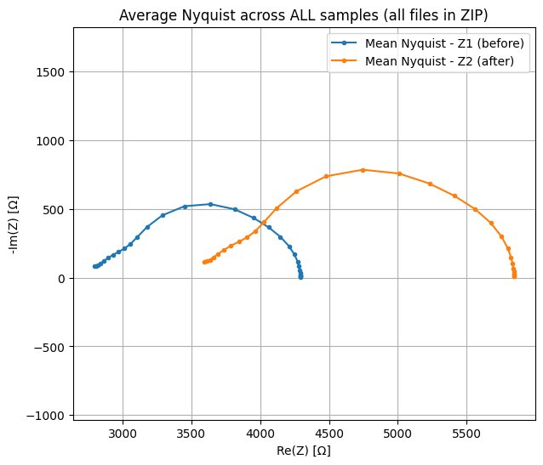

Figure 2: EDA Result: Nyquist Plot For Synthetic Dataset

In this plot, we can calculate the change in the diameter between 2 curves:
$$D_{\text{before}}≈4300-2800=1500 Ω \\ D_{\text{after}}≈5850-3550=2300 Ω$$
The average Nyquist semicircle diameter increased from approximately
1500 Ω before the fluid change to approximately 2300 Ω after the fluid change. This corresponds to an increase of about 800 Ω, or approximately 50–53%. Therefore, the synthetic dataset shows a clear and consistent change in the Nyquist representation.

Implementation
The proposed system is a wearable bioimpedance monitoring device that estimates changes in tissue fluid content by measuring impedance across multiple excitation frequencies and processing the results through a machine learning pipeline trained on Cole-Cole spectral features. The full target architecture includes an AFE, a BLE MCU, and a wireless power and battery management subsystem. All considerations are described in the previous Planning section.
In the scope of this project, the signal chain and measurement methodology were validated through a controlled tissue phantom experiment using the MAX30001G evaluation kit as the measurement platform, in place of the planned wearable hardware.

4.1 Hardware Description
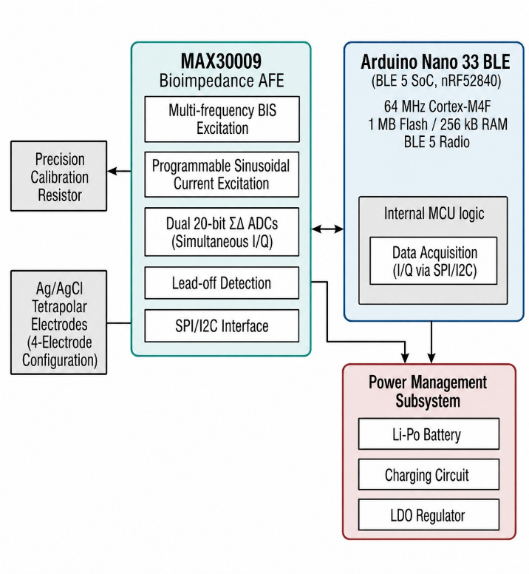
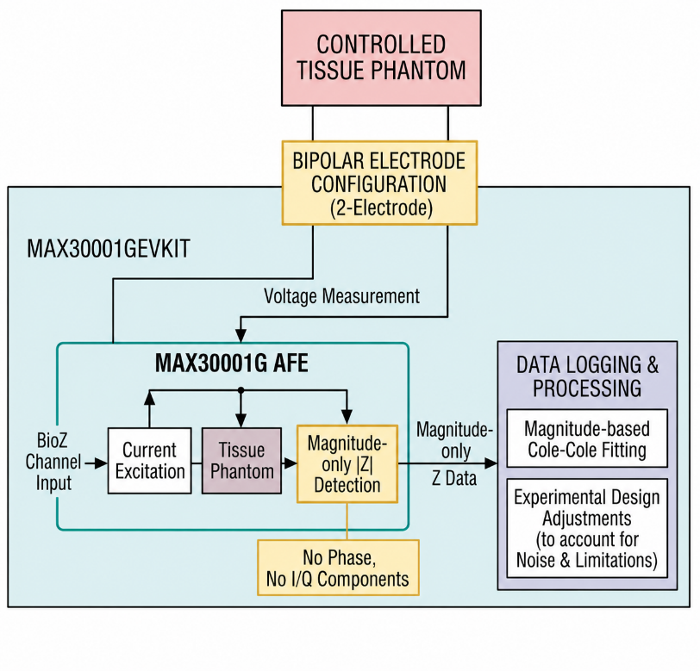
Bioimpedance measurements were performed using the MAX30001GEVKIT (Analog Devices), an evaluation platform for the MAX30001G - a single-chip AFE integrating a bioimpedance (BioZ) acquisition channel. In the intended wearable system, the AFE chip would be embedded on a custom PCB alongside the BLE MCU and power management circuitry. Here, the EV kit serves as a functionally equivalent substitute.
Figure 3: Recommended Product Architecture (left) Phantom Experiment Setup (right)
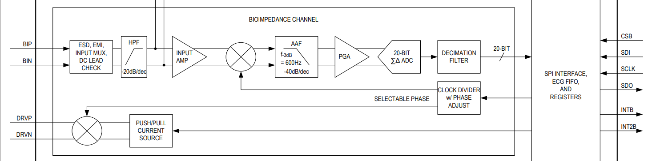
The BioZ signal chain:
Figure 4: Bioimpedance channel block diagram, MAX30001G datasheet, ADI.

In the target wearable architecture, based on the MAX30009 AFE, an internal AC current generator injects a sinusoidal excitation into the tissue via DRVP/DRVN. The resulting differential voltage is sensed at BIP/BIN, amplified by an INA, and demodulated by in-phase (0°) and quadrature (90°) mixers - directly recovering the real and imaginary components of Z(ω). Each channel is filtered, amplified by a PGA, and digitized by a 20-bit ADC. Measurements are logged as CSV files for Cole-Cole feature extraction and model inference.

Measurements are performed in a two-electrode configuration. A 220 nF DC-blocking capacitor is placed in series with each drive electrode.

The single demodulator output of the MAX30001 approximates the impedance magnitude |Z| (a projection of the impedance vector onto the phase axis) rather than separate real and imaginary components allowed by two demodulators in MAX30009.

4.2 Phantom Experiments
To validate the proposed bioimpedance measurement chain and analysis methodology, two controlled ex-vivo phantom experiments were performed using the MAX30001GEVKIT. The general objective of these experiments was to evaluate whether impedance measurements can detect changes in ionic and fluid content in biological-like tissue, analogous to conductivity variations expected during physiological processes such as breast milk expression.
The phantom experiments were divided into two main stages. The first experiment was performed using potato tissue and was intended to validate the basic multi-frequency measurement procedure and the Cole-Cole-based analysis method. The second experiment was performed using beef steak tissue, which provides a more realistic soft-tissue structure, and was designed to further evaluate the sensitivity of the device to small injected fluid volumes and to prepare for additional multi-frequency analysis.

4.2.1 Potato Phantom Experiment
The first phantom consisted of two potato samples: a dry sample used as a control and a second sample soaked in saline solution. Saline soaking increases the ionic concentration within the extracellular spaces of the tissue, thereby increasing its effective electrical conductivity and reducing impedance.

Measurements were performed using the MAX30001 in a bipolar, 2-electrode configuration. The drive terminals, DRVP and DRVN, and the sense terminals, BIP and BIN, were shorted using the DP_BP and DN_BN jumpers, resulting in shared current injection and voltage measurement points.

A manual frequency sweep was performed at six discrete frequencies: 125 Hz, 250 Hz, 500 Hz, 1 kHz, 2 kHz, and 4 kHz. A constant excitation current of 110/220 nA was used, with a sampling rate of 32 samples per second and the high-pass filter disabled. At each frequency, the impedance magnitude, $∣Z∣$, was recorded for both the dry and saline-treated samples.

4.2.2 Beef Steak Phantom Experiment
Following the potato experiment, a second phantom experiment was performed using beef steak tissue. This experiment was divided into two parts: a sensitivity test using a small saline injection, and a planned multi-frequency test for Cole-Cole and Nyquist analysis.

- Sensitivity test:
  - In this test, a small volume of saline, 0.2 mL, was injected into the steak tissue. The impedance was measured before and after the injection at a fixed frequency of 4 kHz.
  - The purpose of this test was to determine whether the MAX30001G can detect a small and localized change in fluid content. This experiment is directly related to the project requirement of detecting small volume changes and is therefore analyzed in detail in the following section.
- A multi-frequency measurement:
  - In this stage, 1mL of conductive saline solution was added to the steak tissue, and impedance measurements were performed at several frequencies.
  - The goal of this experiment is to analyze the frequency-dependent impedance behavior and to reconstruct Cole-Cole and Nyquist representations of the tissue response.

This analysis, with the potato phantom results provided a strong basis for evaluating whether the system can detect fluid-induced conductivity changes using spectral bioimpedance features.

Overall, the two phantom experiments serve complementary purposes. The potato experiment validates the basic measurement and modeling methodology under controlled conditions, while the steak experiment evaluates the sensitivity and practical behavior of the system in a more realistic soft-tissue phantom. Together, these experiments provide an initial experimental basis for using bioimpedance measurements to detect small fluid-related changes in biological tissue.

4.3 Software Description
The machine-learning part of the project was implemented as a supervised regression task. Each sample represents the bioimpedance response between two measurement time points, and the target value is the corresponding change in fluid volume in milliliters.
We examined several machine learning implementations in order to evaluate the relationship between the extracted bioimpedance features and the target milk volume change. The models differed both in the type of input features and in the learning algorithm used.
The main goal of this comparison was to evaluate the performance of different regression models and input representations, and to determine which approach is most suitable for estimating milk-volume changes from bioimpedance data.

4.3.1 Implementation Environment
The project was implemented in Python. Gradient-boosted tree modeling was performed using the LightGBM library. Neural network models were built and trained using PyTorch, with data handling supported by NumPy and pandas. Cole-Cole parameter fitting was carried out using the SciPy nonlinear least-squares optimizer. Trained models and preprocessing objects were saved to disk using joblib, and training results were visualized using Matplotlib.
All three models share a common data pipeline. The bioimpedance system simulates the electrical response of tissue across four electrode pairs placed at different positions. For each pair, a CSV file contains the simulated impedance spectra at two time points, before and after a fluid change event, along with the computed difference spectrum. These files are loaded and merged so that each row in the synthetic dataset represents a single observation: one pair of time points, combining the measurements from all four electrode pairs into a single wide feature vector. The dataset is then split into training, validation, and test sets at the replicate level, meaning all rows belonging to the same experimental replicate are kept together in the same split. This prevents any form of data leakage between the sets.

4.3.2 The Models
LightGBM is a gradient-boosted decision tree model whose input combines two types of features. The first type is physics-informed: Cole-Cole parameters fitted to the impedance spectra of each electrode pair, their differences between the two time points, and additional spectral summaries such as impedance magnitude, phase angle, and the ratio between low and high-frequency responses. The second type is the raw impedance-difference spectrum, that is the real and imaginary parts of the measured spectral change across all 30 frequencies, appended directly alongside the engineered features. This combination gives the model access to both compact, theory-grounded descriptors and the full measured spectral change. The model was trained with early stopping based on validation loss, using up to 2000 estimators with a learning rate of 0.05.
The MLP (Multilayer Perceptron) is a fully connected neural network trained directly on the raw impedance spectra, without any prior feature engineering. For each observation, the input consists of the real and imaginary impedance values of Z1, Z2, and ΔZ measured at 30 frequencies across all four electrode pairs, yielding 720 spectral values. The time elapsed between the two measurement points is appended as an additional scalar input, bringing the total input dimension to 721. These inputs are fed into three successive fully connected layers of sizes 512, 256, and 128, each followed by batch normalization, ReLU activation, and dropout for regularization. The model was trained using the Adam optimizer with a learning rate scheduler that reduces the learning rate when validation loss stops improving, and training is halted early if no improvement is observed over a fixed number of epochs.
The 1D CNN (One-Dimensional Convolutional Neural Network) is a convolutional neural network designed to detect patterns in the impedance spectra along the frequency axis. Rather than flattening all spectral values into a single vector, the input is structured as a set of parallel signal channels: for each electrode pair, the six impedance components (real and imaginary parts of Z1, Z2, and ΔZ) are each treated as a separate 1D signal over the 30 measured frequencies, giving 24 channels in total. Three convolutional layers progressively extract local frequency-domain patterns from these channels, followed by pooling to compress the representation. The time scalar is then concatenated to this compressed representation and passed through a small fully connected head to produce the final prediction. The model was trained using the same optimizer and scheduling strategy as the MLP.
4.3.3 Feature Representations
Two main feature representations were tested. The first was based on physics-informed feature extraction. Rather than passing the raw spectra directly to the model, each spectrum was first summarized using the Cole-Cole model, which is a standard parametric model in bioimpedance analysis that describes the frequency-dependent electrical response of biological tissue using four parameters: low-frequency resistance ($R_{0}$), high-frequency resistance ($R_{∞}$), characteristic frequency ($f_{c}$), and dispersion exponent ($α$). These parameters were fitted separately for the impedance spectra measured at each of the two time points and for each electrode pair. The difference between the fitted parameters at the two time points was also computed, capturing how the tissue's electrical properties changed. Additional descriptors were extracted directly from the spectral shape, including impedance magnitude, phase angle, and frequency-band ratios. The raw impedance-difference spectrum was appended alongside these features so that no measured information was discarded.
The second representation used the raw impedance spectra directly, without any prior compression or interpretation. The model received the complete set of real and imaginary impedance values across all measured frequencies, and was left to discover relevant patterns during training. This approach was used for the MLP and 1D CNN models.
The comparison between these two approaches was designed to evaluate whether a model benefits more from receiving structured, theory-grounded features or from learning directly from the complete spectral data.

Analysis of results
The results are divided into two parts. The first one focuses on the machine learning pipeline. We will compare the different model implementations that were tested for milk volume estimation for synthetic dataset. The second part presents the planned experimental validation using the MAX30001G evaluation kit, which was used to acquire bioimpedance measurements from biological samples such as potato and steak.
For implementing the project, we defined 3 measurable goals:
- RMSE ≤ 5% of measurement range.
- Detect at least 30% change in the diameter of the Nyquist curve after fluid change.
- Device Sensitivity of 0.2 mL.

5.1 Machine Learning
The tested models were evaluated using standard regression metrics: Mean Absolute Error (MAE), Root Mean Squared Error (RMSE), and the coefficient of determination $R^{2}$.
Model | R² | RMSE (mL) | MAE (mL)
LightGBM | 0.914 | 7.07 | 4.04
MLP | 0.716 | 12.84 | 8.59
1D CNN | 0.680 | 13.63 | 9.38
Table 2: Models comparison
- MAE represents the average absolute prediction error in milliliters.
- RMSE gives higher weight to larger errors.
- $R^{2}$ measures how well the model explains the variation in the target volume change.

The best performance was achieved by the LightGBM model trained on physics informed bioimpedance features. This model obtained the highest $R^{2}$ score and the lowest error values among the tested implementations and reached the measurable goal of RMSE ≤ 5% of the measurement range.

The result suggests that, for this dataset, structured feature engineering based on the Cole-Cole model and impedance spectrum summaries was more effective than using the raw spectra directly.
The low MAE indicates that the average prediction error is relatively small compared to the typical volume range, while the high $R^{2}$ value shows that the model captures a significant part of the relationship between bioimpedance changes and milk-volume variation.
At the same time, the difference between MAE and RMSE indicates that the model still makes occasional larger errors. These larger errors are expected to appear mainly in more challenging cases, such as larger volume changes or longer time gaps between measurements. In the context of our project, this behavior is acceptable, since the system is intended for real time monitoring, where the model is expected to estimate gradual volume changes over relatively short time intervals. Large milk volume changes over very short periods are less physiologically likely, so emphasizing shorter time differences better matches the intended use case.

The results also showed that combining the two features representations, as done in the LightGBM model which received both the Cole-Cole features and the raw ΔZ spectrum, achieved the best prediction performance.

5.2 Phantom Experiments
This section presents the results obtained from the ex-vivo phantom experiments. Two types of tissue phantoms were evaluated: a potato phantom and a beef steak phantom.

5.2.1 Potato Phantom Experiment
The measured impedance magnitude |Z| for both samples across frequency is summarized below:

Frequency | Dry (kΩ) | Saline (kΩ) | Δ%
125 Hz | 870.4 | 871.5 | +0.1%
250 Hz | 759.3 | 761.8 | +0.3%
500 Hz | 571.8 | 525.7 | −8.1%
1 kHz | 359.9 | 311.8 | −13.4%
2 kHz | 199.6 | 130.3 | −34.7%
4 kHz | 103.2 | 36.2 | −64.9%
Table 3: Potato Experiment results
In bioimpedance measurements, the measured tissue compartment depends strongly on the excitation frequency. At low frequencies, the current is mostly limited to extracellular paths because cell membranes behave as insulating capacitive barriers. Therefore, this frequency range is especially sensitive to extracellular conductive fluids, such as breast milk or saline solution. Although 4 kHz is the highest frequency used in our potato phantom experiment, it is still considered part of the low-frequency bioimpedance range and therefore remains mainly sensitive to extracellular ionic conductivity rather than deep intracellular conduction.

At low frequencies (125–250 Hz), both samples exhibited nearly identical impedance values. This is primarily attributed to the dominance of electrode-electrolyte polarization impedance in the bipolar measurement configuration, which can obscure tissue-related differences at low frequencies. Under these conditions, the measured impedance is largely governed by the electrode interface rather than the bulk tissue properties.

As frequency increases, the influence of electrode polarization decreases, and the measured signal becomes increasingly sensitive to the bulk conductivity of the tissue. In this regime, clear differences emerge between the samples: the saline-treated potato exhibits significantly lower impedance than the dry sample, consistent with increased ionic conductivity due to the saline solution. The effect becomes progressively stronger with frequency, reaching a 34.7% reduction at 2 kHz and 64.9% at 4 kHz.
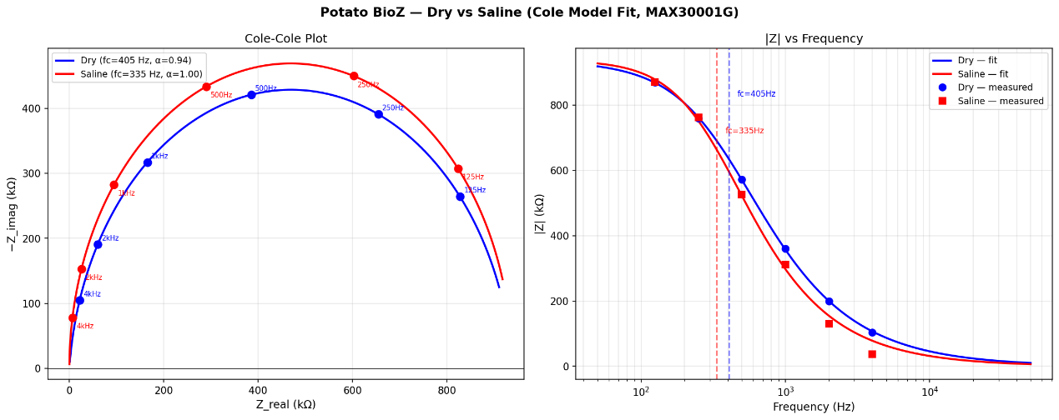
Cole-Cole Model Fitting - Potato Phantom
Figure 5: Dry vs Saline Bode Plot

Parameter | Dry | Saline
$$R_{0}$$ | 939 kΩ | 938 kΩ
$$R_{∞}$$ | ~0 Ω | ~0 Ω
$$f_{c}$$ | 415 Hz | 343 Hz
$$α$$ | 0.94 | 1.00
The measured magnitude spectra were fitted to a Cole-Cole model to extract equivalent tissue parameters. The resulting parameters were:
Table 4: Cole-Cole Parameter Fitting
The low-frequency resistance $R_{0}$ was similar for both samples, which is consistent with the observation that low-frequency measurements are dominated by electrode polarization effects in this configuration, rather than intrinsic tissue differences.

5.2.2 Beef Steak Phantom Experiment
Following the potato experiment, a beef steak phantom was used to evaluate the sensitivity of the system in a more realistic soft-tissue sample.

Sensitivity Test: 0.2 mL Saline Injection at 4 kHz
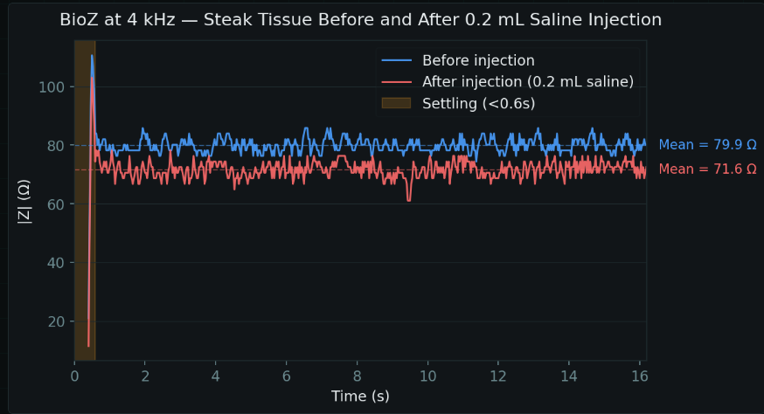
The first steak experiment was designed to test whether the system could detect a small volume change. 0.2 mL saline was injected into the steak tissue, the BioZ signal was measured before and after injection at 4 kHz.
Figure 6: Sensitivity Test Results
Condition | Mean BioZ (Ω)
Before saline injection | 79.9
After 0.2 mL saline injection | 71.6

Table 5: Sensitivity Test Results

The measured impedance decreased by approximately 8.3 Ω, corresponding to a relative reduction of approximately 10.3%.

This result demonstrates that the MAX30001GEVKIT measurement chain is sensitive enough to detect a small injected volume of conductive fluid in ex-vivo soft tissue, reaching the project sensitivity goal. The impedance decrease is consistent with the expected increase in ionic conductivity caused by the saline solution.

Multi-Frequency Experiment
Frequency [Hz] | |Z| Before Saline [Ω] | |Z| After Saline [Ω] | Change [%]
125 | 335 | 178 | -47%
500 | 319 | 172 | -46%
2k | 283 | 155 | -45%
8k | 259 | 137 | -47%
40k | 252 | 131 | -48%
128k | 251 | 131 | -48%
Table 6: Multi Frequency Experiment Results

The experiment showed a clear decrease in impedance magnitude after saline injection across the entire measured frequency range. Before saline injection, the impedance decreased from 335 Ω at 125 Hz to 251 Ω at 128 kHz. After saline injection, the impedance decreased from 178 Ω at 125 Hz to 131 Ω at 128 kHz.

This behavior is consistent with the expected electrical response of biological tissue. Saline contains ions that increase the conductivity of the extracellular fluid. As a result, the tissue becomes more conductive and the measured bioimpedance decreases.

The results show that the system is sensitive to frequency-dependent impedance behavior. In both the before-saline and after-saline measurements, the impedance magnitude decreased as frequency increased. This is expected in biological tissue because cell membranes behave capacitively, allowing more current to pass at higher frequencies.

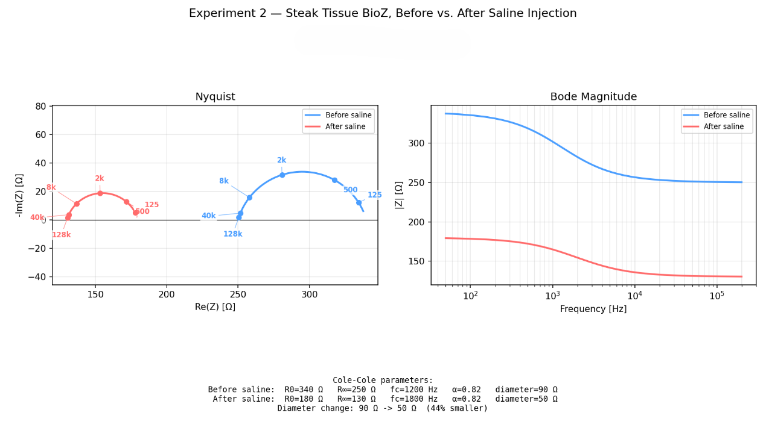
Cole-Cole Model Fitting - Steak Phantom
Figure 7: Multi Frequency Experiment Results
Condition | $R_{0}$ [Ω] | $R_{∞}$ [Ω] | $f_{c}$ [Hz] | $$α$$ | Diameter [Ω]
Before saline | 340 | 250 | 1200 | 0.82 | 90
After saline | 180 | 130 | 1800 | 0.82 | 50

Table 7: Multi Frequency Experiment Results
The Nyquist reconstruction provides an additional representation of the same conductivity change. Before saline injection, the Nyquist curve had a larger semicircular arc, with a fitted diameter of approximately 90 Ω. After saline injection, the curve shifted to lower real impedance values and the semicircle diameter decreased to approximately 50 Ω. This corresponds to a diameter reduction of about 40 Ω, or approximately 44%.

This behavior is consistent with the expected Cole-Cole response of biological tissue. When saline is injected, the extracellular ionic conductivity increases, causing the overall tissue resistance to decrease. As a result, both $R_{0}$ and $R_{∞}$ decrease, and the Nyquist semicircle becomes smaller. The fitted parameters support this trend: $R_{0}$ decreased from 340 Ω to 180 Ω, while $R_{∞}$ decreased from 250 Ω to 130 Ω.

Therefore, the Nyquist results confirm that the saline injection caused a clear conductivity-related change in the steak tissue. The 44% decrease in semicircle diameter exceeds the project target of detecting at least a 30% change in Nyquist diameter, supporting the validity of the multi-frequency measurement approach.

Because the MAX30001G provides magnitude-only data, this Nyquist curve is based on Cole-Cole reconstruction rather than direct complex impedance measurement. Still, the result is consistent with the measured Bode magnitude response and supports the conclusion that the system can detect fluid-related conductivity changes across multiple frequencies.

Conclusions and further work
This project aimed to develop a proof-of-concept system for estimating breast milk volume changes using bioimpedance measurements and a regression-based machine learning model.

6.1 Project results against the goals
Our work plan defined both system-level and algorithmic goals:
- On the system side - the goal was to design a wearable, non-invasive breast sensor that could perform safe and user-friendly real-time measurements using a microcontroller-based architecture.
- On the device-validation side:
  - The system was expected to detect a significant impedance change in a controlled tissue experiment, including at least 30% change in the diameter of the Nyquist curve after a fluid-related change.
  - Reach a target volume sensitivity of 0.2 mL.
- On the machine-learning side:
  - The defined performance target was an RMSE not exceeding 5% of the measurement range.
The machine-learning goal was successfully achieved in the project. As we explained in chapters 4 and 5, several regression models were implemented and compared, including LightGBM, MLP, and 1D CNN. The best performance was obtained with LightGBM. The final LightGBM model achieved an ($R^{2}$) value of 0.914, an RMSE of 7.07 mL, and an MAE of 4.04 mL. For the synthetic dataset used in this project, this RMSE is within the required order of 5% of the measurement range, which is 142 mL.
Therefore the ML target was considered achieved at the data-analysis level.

The hardware and device-validation goals were also achieved. The final planned wearable architecture was designed around the MAX30009 AFE and Arduino Nano 33 BLE, which would allow compact multi-frequency bioimpedance measurement and wireless data transmission. However, due to component availability and project-time constraints, the final wearable system was not fully implemented. Instead, experimental validation was performed using the MAX30001G evaluation kit in a controlled phantom experiment.

The phantom experiments supported the basic sensing principle of the project. In the potato experiment, a dry potato sample was compared with a saline-treated potato sample, in order to evaluate whether the measurement setup could detect conductivity-related changes in biological tissue. The measured results showed that the saline-treated sample had lower impedance than the dry sample at higher frequencies.

To further evaluate hardware sensitivity, an additional steak phantom experiment was performed. In this experiment, 0.2 mL of saline was injected into beef steak tissue, and the impedance was measured before and after injection at 4 kHz.

This result experimentally supports the device sensitivity target of detecting a 0.2 mL conductive fluid change under controlled ex-vivo conditions. The decrease in impedance is consistent with the expected increase in ionic conductivity caused by the saline injection.

A second steak experiment was then performed to evaluate the frequency-dependent response and the Nyquist-related project requirement. In this experiment, the steak tissue was measured over a frequency sweep from 125 Hz to 128 kHz, before and after injection of 1 mL saline. The purpose was to extend the single-frequency sensitivity result to a broader impedance spectrum and analyze the effect of the added ionic conductivity on the fitted Cole-Cole response.

The fitted Cole-Cole parameters showed a clear decrease in both low-frequency and high-frequency resistance after saline injection.

Overall, the hardware experiments showed that the proposed measurement chain can detect fluid-related conductivity changes in biological tissue phantoms. The potato experiment validated the general frequency-dependent conductivity response, the first steak experiment supported the 0.2 mL sensitivity target, and the second steak experiment supported the 30% Nyquist-diameter change target through Cole-Cole-based reconstruction.

However, the Nyquist-related result should still be interpreted carefully. The MAX30001G provides impedance magnitude ∣Z∣ only, without direct phase information, so the Cole-Cole and Nyquist curves were reconstructed by model fitting rather than directly measured as full complex impedance. Future validation should therefore include repeated trials, multiple injected volumes, and direct complex impedance acquisition using hardware capable of measuring both magnitude and phase. This would allow more reliable estimation of Cole-Cole parameters and stronger validation of Nyquist-based metrics in physiological conditions.

6.2 Improve system performance & Possibilities for future development
Overall, the project achieved its main proof-of-concept goals in software and the hardware-validation goals. The ML pipeline demonstrated that impedance-derived features can predict fluid-volume changes with promising accuracy, and the phantom experiment confirmed that conductivity changes can be detected using bioimpedance measurements.

Future work should first focus on implementing the final hardware architecture using the MAX30009 AFE. This would allow acquisition of full complex impedance data, including both in-phase and quadrature components, and would enable direct evaluation of Nyquist-curve changes. A tetrapolar electrode configuration should also be used in order to reduce electrode-skin contact impedance and improve measurement stability, especially at low frequencies.
Future experiments should use controlled tissue or breast phantoms with known geometry, conductivity, and fluid-volume changes.

The machine-learning model should also be evaluated on real measured data rather than synthetic data only. Real measurements are expected to include additional noise sources, motion artifacts, electrode-placement variability, and subject-to-subject differences. Therefore, future work should include the collection of a larger and more realistic dataset, testing of model generalization, and possibly the development of personalized calibration models for different users.

Project Documentation
All project deliverables are to be documented (e.g. GitHub), this final project report should only include their description:
- Description of the project documentation (Hardware, software, additional simulations, user guide, etc.)
- The Documentation location (e.g. the GitHub link)
- Description of the project files

References
Here are some examples of references, and how they should be included.
Books:
- A. M. Bronstein, M. M. Bronstein, and R. Kimmel. "Numerical geometry of non-rigid shapes”, Springer-Verlag New York Inc, 2008.
Papers:
- G. B. Giannakis , "Highlights of Signal Processing for Communications", IEEE Signal Processing Magazine, Vol. 16, no 2, pp. 14-49, March 1999
Datasheet
- “Spartan-3A DSP FPGA Family Data Sheet”, XILINX Product Specification DS610, October 4, 2010. http://www.xilinx.com/support/documentation/data_sheets/ds610.pdf
- MAX30001G EVAL KIT datasheet, Analog Devices.
https://www.analog.com/media/en/technical-documentation/data-sheets/max30001g.pdf
Application Note :
- X. Zhang, "Developing a CCStudio 2.0 DSP/BIOS Application for FLASH Booting on the TMS320C5402 DSK", TI Application Report SPRA661A, November 2000. http://www.ti.com/lit/an/spra661a/spra661a.pdf
User's Guide:
- "TMS320C6201/6701 Evaluation Module User's Guide", SPRU269F, August 2002
- Code Composer Studio IDE 2.0 online help.
Links:
- "Dolby E Multichannel Coding for DTV Audio Production and Distribution", http://www.dolby.com/tech/m.br.9903.epaper.pdf
- G. Welch and G. Bishop – "An Introduction to the Kalman Filter", http://www.cs.unc.edu/~welch/kalman/kalman_filter/kalman.html http://www.cs.unc.edu/~welch/kalman/kalman_filter/kalman.html#pgfId-11854
- C. Mercer, "Smoothing Spectral Data", The PROSIG Digital Signal Processing Tutorials, http://www.prosig.com/signal-processing/smoothingspectra.html

- Subject 1
If you need to go into details of a specific subject, you should do it here.
A dedicated appendix should be included for each subject.

- Subject 2

The machine-learning part of the project was implemented as a supervised regression task. Each sample represents the bioimpedance response between two measurement time points, and the target value is the corresponding change in fluid volume in milliliters.

We examined several machine learning implementations in order to evaluate the relationship between the extracted bioimpedance features and the target milk volume change. The models differed both in the type of input features and in the learning algorithm used. The main goal of this comparison was to determine whether physically meaningful feature extraction improves prediction accuracy compared to using the raw impedance spectra directly.

The models:

- LightGBM -input representation based Cole-Cole and spectral features. This is a Gradient boosted decision tree model trained on engineered bioimpedance features.
- MLP - input representation based raw impedance spectra. This is a fully connected neural network trained directly on raw spectral data.
- 1D CNN - input representation based raw impedance spectra. This is a convolutional neural network trained to learn patterns across the frequency axis.

Two main feature representations were tested. The first representation was based on physics informed feature extraction. In this approach, the raw impedance spectra were processed using the Cole-Cole model, which summarizes each spectrum using parameters such as low frequency resistance, high frequency resistance, characteristic frequency, and dispersion exponent. Additional spectral features and impedance-difference features were also included in order to describe how the impedance response changes between two measurement time points.

The second representation used the raw impedance spectra directly. In this case, the model received the real and imaginary impedance values across the measured frequency range, without first compressing the spectrum into physically interpretable parameters. This approach was tested mainly with neural network models, MLP and 1D CNN.

The comparison between these approaches allowed us to evaluate whether the model benefits more from learning directly from the raw spectra or from receiving a structured representation based on bioimpedance theory.
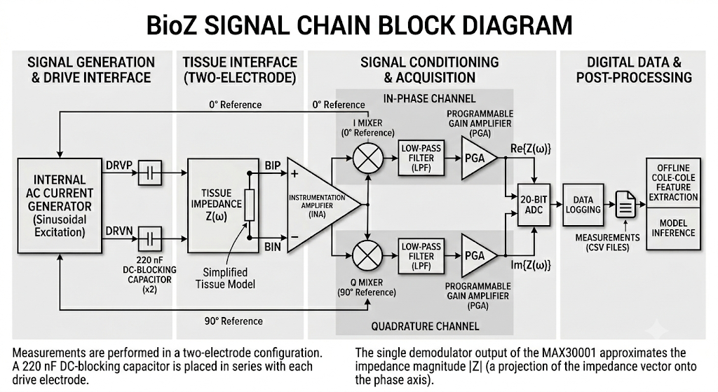

1 Kim, J. et al. “A compact, wireless system for continuous monitoring of breast milk expressed during breastfeeding.” Nature Biomedical Engineering, 2025.

